Final Race Instructions
Its Grim up North Running – Glorious Gargrave

GOVERNING BODY: The Trail Running Association

Sunday 4th June

RACE HEADQUARTERS:

Gargrave Cricket Club, Gargrave, Skipton BD23 3SD

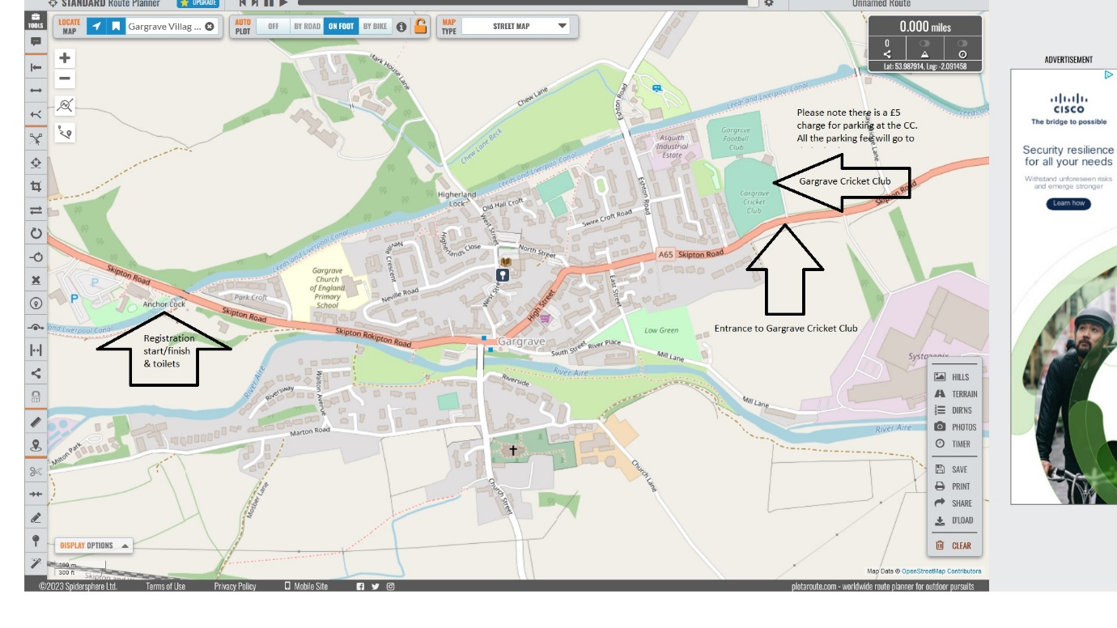

GETTING TO US AND PARKING

See map above. Please note there is a £5 parking donation, which will go directly to the Cricket Club charity.

FACILITIES

Toilets are available at the start and finish area.

GRIM MASSAGE

Adam will be available for both pre-race and post-race massage. He his brilliant. You can pay by either cash or card.

REGISTRATION
(See map) – Near the Anchor Inn Pub, we’ll put a large registration sign out.

Distance | Registration opens | Start
Ultra | 08:45 | 09:30
Marathon | 08:45 | 09:30
20 Miler | 09:30 | 10:00
Half Marathon | 10:00 | 10:30
10k | 08:00 | 09:00
5k | 07:45 | 08:30

BAGGAGE DROP

There will be a baggage drop, in the Grim van which will be available at the start and finish area.

THE ROUTE

The route is measured by Plot-a-route and Garmin.

5k - https://www.plotaroute.com/route/2263793

10k - https://www.plotaroute.com/route/2263797

Half marathon - https://www.plotaroute.com/route/2263804

20 Miler - https://www.plotaroute.com/route/2263810

Marathon – 20 Miler route, then 10k route.

Ultra – 10k route, marathon, 10k route

ROAD CROSSINGS: There are a couple of road crossings on this route, please take extra care. Signs will warn you the runner about the crossing and signs will be placed warning other road users.

Water and feed station approx. every 3/4 miles. Marshals will be placed along the route.

RACE SHOES

Weather dependant – if wet trail shoes.

DURING THE RACE

Please do not litter, take all gel wrappers etc with you or leave with a marshal.

We hope to start all the races promptly. Please inform a race official if you are unable to complete the course and need to withdraw for any reason, please hand your race number to the official. Please assist officials by making sure your number is visible. Always wear your race number on the front of your vest.

Please be aware of all other users of the Canal and be kind and courteous.

THE RACE

The race starts and finishes in the same place.

WATER AND FEED STATIONS

This is cupless event. All runners are requested to bring their own labelled, reusable cup or bottle. We are happy to fill your bottles before, during and after the event. We’ll have feed stations every 2/3 miles. We’ll provide water, squash, cola as well as crisps and savoury snacks. Please use the bins provided. If you don’t have your own bottle/cup, we sell reusable, squashable cups for £5.

HEADPHONES
We do not want to spoil the enjoyment of the event for the competitors, but we do not endorse the use of MP3 players, or similar devices, for the following safety reasons:
Runners cannot always hear the marshals’ instructions.
Runners may not hear cyclists behind them and stray into their path.
Bone conduction earphones are allowed.

YOUR REWARD AT THE END

Relief, Joy and happiness.
Become a Hero.
Bespoke medal
All our events have lots of lovely things at the finish line. As we love to celebrate every runners’ achievements. All our runners are winners.

WEATHER

Please keep an eye on the forecast and dress appropriately.

GRIM Looks forward to welcoming you next week.

